## Step 1: Select Dataset

After searching through datasets on various websites, I eventually decided upon “*Spotify Musical Features of 160+ Holiday Songs*”1, compiled and analyzed by *@promptcloud*. The fact that they have provided their own analysis with visualizations will be useful for developing my own, however I must be careful not to plagiarize their work.

The data is stored in a .csv file, designed for use with spreadsheet applications such as excel, and I will need to convert it to JSON.

## Step 2: Convert to JSON:

This was relatively trivial; achieved using an online tool2.

## Step 3: Designing HTML (and CSS)

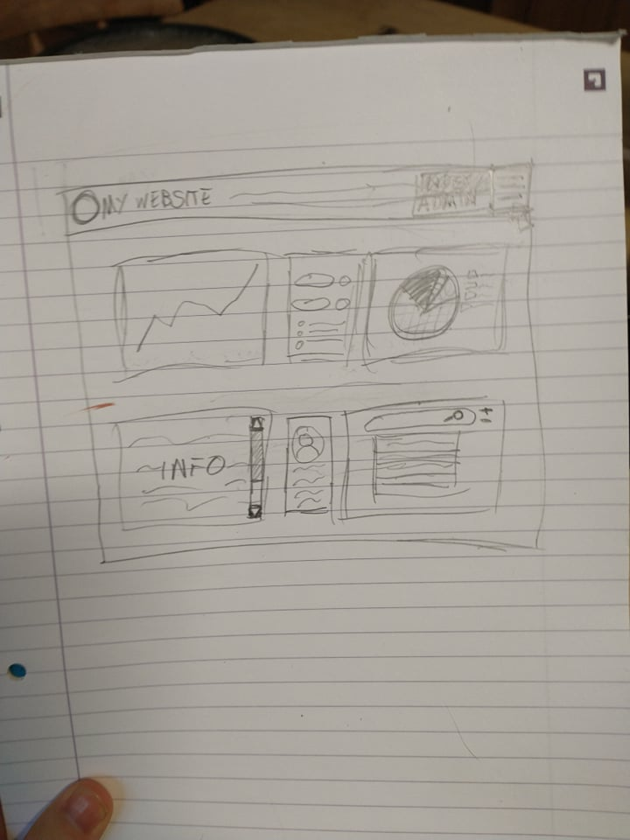

*A rough sketch of what my layout might look like, drawn before I even selected my dataset.*

As my webpage is specifically about Christmas (or Holiday) music, I have elected to use a Christmas-themed colour scheme3. 

I am going to use the ‘Spectral’ font for headings and the ‘Rubik’ font for text.